**1. System Initialization:**

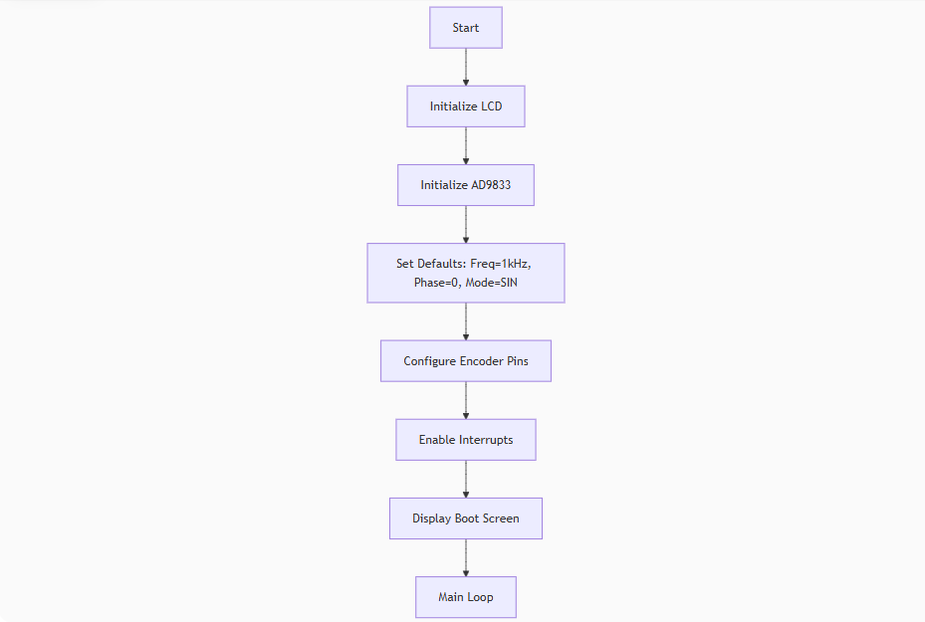

**2. Main Program Loop**:

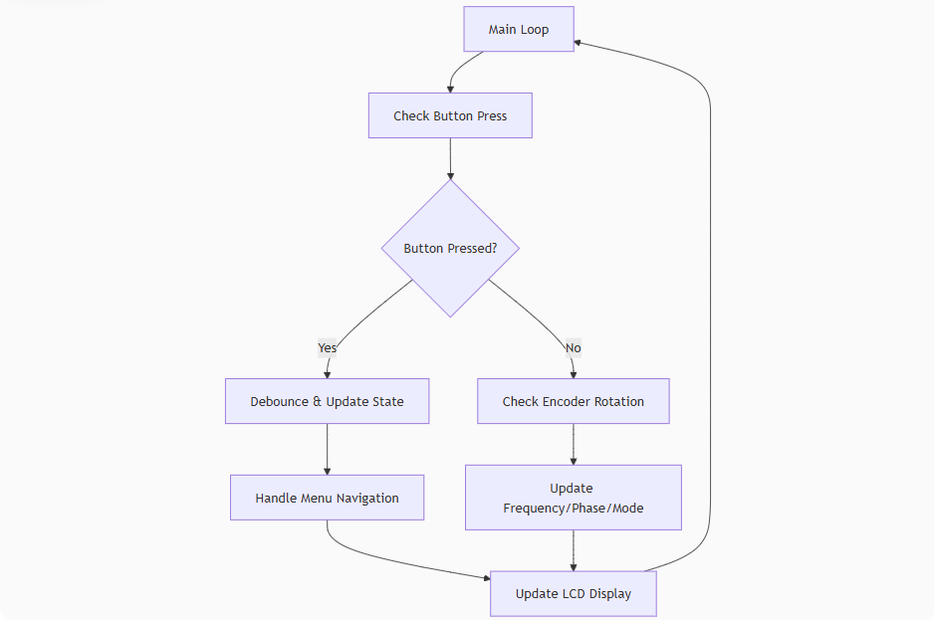

**3. Menu State Machine:**

**4. Encoder Interrupt Handler**:

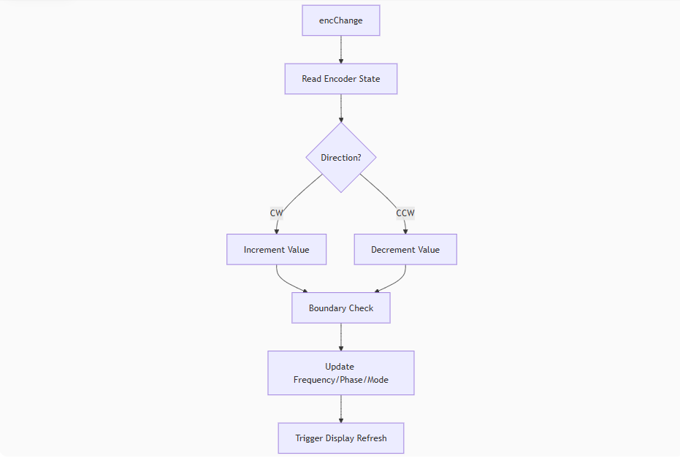

**5. LCD Display Logic**:

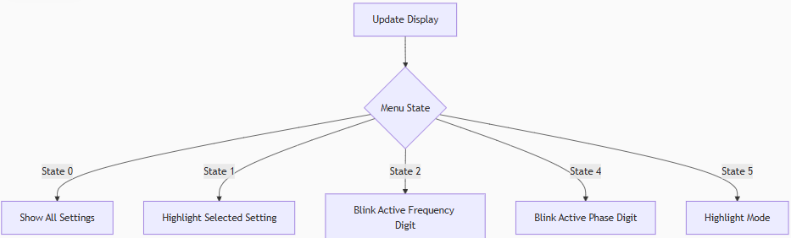

**6. AD9833 Control Flow**:

